This document provides instructions on setting Kasa device preferences using the Kasa SmartThings Service Manager. Preferences can also be set on each device using the phone application; however, this tool allows setting preferences on multiple devices at a single time. The preferences that can be set are:

1. **Refresh Rate**. This is the period between refreshing of the device. The default of 30 minutes is suitable for 90% of the use cases; however, rates as fast as once every minute are allowed for user selection. Note: The faster the refresh rate, the more SmartThings cloud resources are consumed by your installations.
2. Lighting Transition Time. This is the time for the light to go from off to the set brightness in **seconds**. It provides a nice effect for even day-to-day operations. Note that extremely long times can cause the light to appear not to be working. I personally recommend no greater than 10 for this period. I use 2 seconds to allow the bulbs to appear to fade in. For plugs and switches, this parameter is ignored.

# Update Instructions

1. Start the Service Manager using the phone application.
2. Expand Set Device Preferences and select in the open field label “Set Device Preferences”.

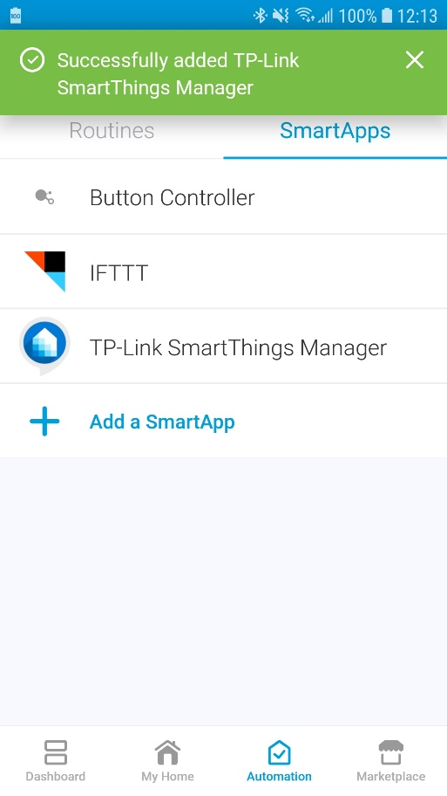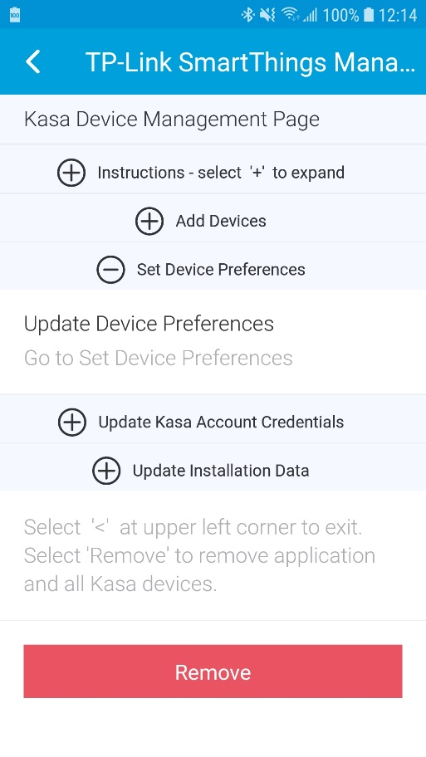

1. Select the open field “Tap to set”
2. Select the devices to have preferences changed then select “Done” at the upper right of the page.

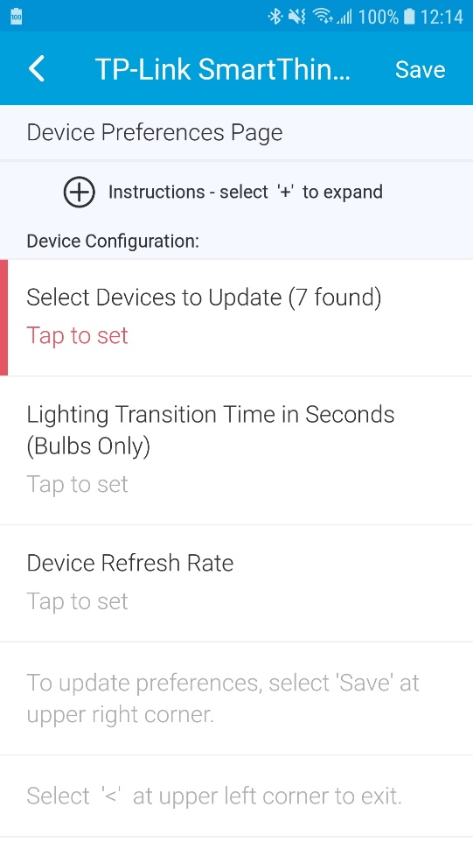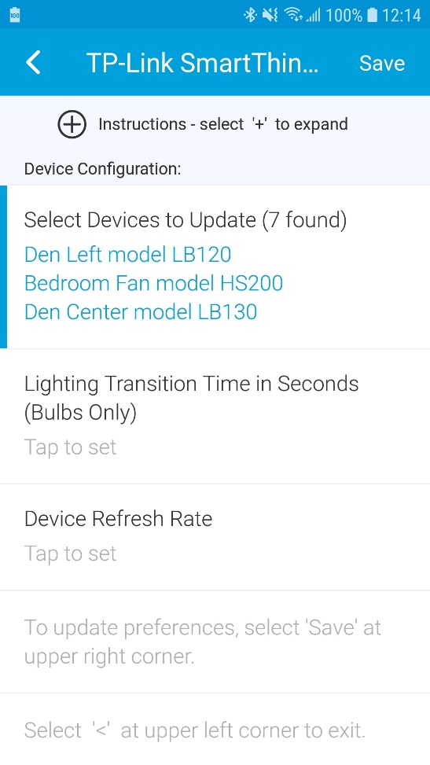

1. Optional: Select the open field under “Lighting Transition Time in Seconds Bulbs Only). Then enter the desired transition time.

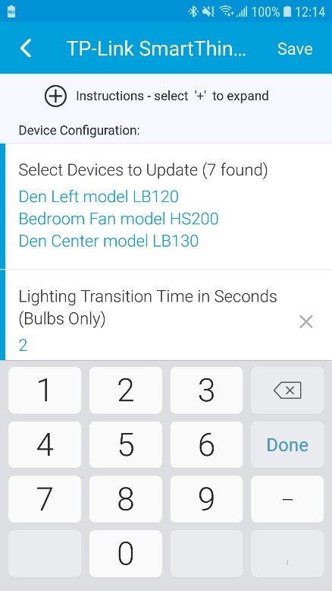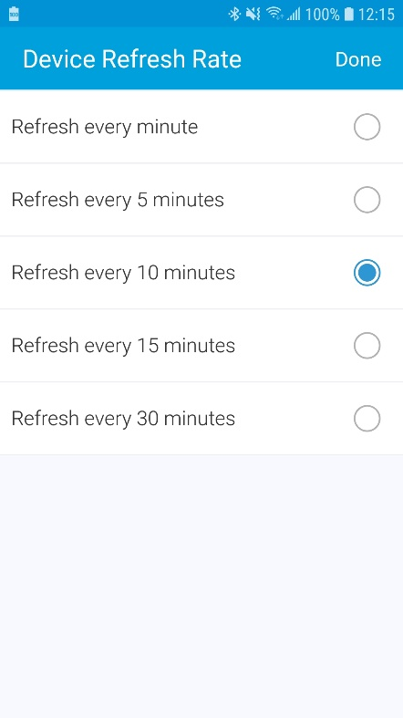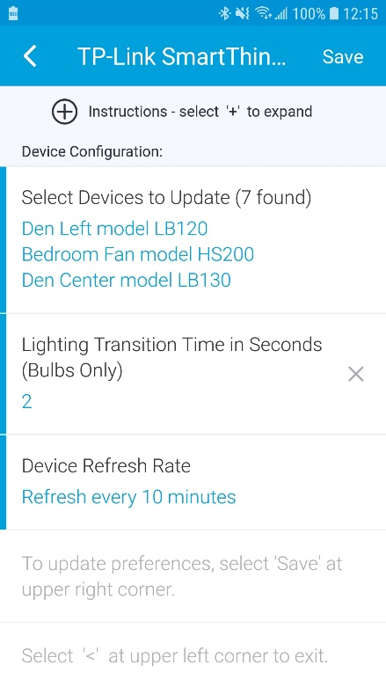

1. Optional: Select the open field under “Device Refresh Rate”
2. Select the desired Refresh Rate from the next window.
3. When done, select “Save” at the upper right of the page. NOTE: “select ‘Save’” has been genericized in app to “select the text”.

The application will update the selected device preferences and exit.

